Q3 – Segmentation: Student Programs with Separate Code, Stack and Data
CSA04 – Operating Systems | Bloom's Level: K5 – Evaluate | 6 Marks
How the evidence was produced: the programs in the appendices were compiled and run on a Linux 6.18 virtual machine (x86-64, 4 KB pages). The segment-table translator is a model of the hardware, because modern 64-bit Linux does not use segment tables. The segmentation fault, /proc maps and table-size results come from real runs. Addresses in /proc/maps change on every run because of ASLR, so yours will differ.

1. Implementation

1.1 Translating (segment, offset) with a segment table
A logical address is a pair (s, d): segment number s and offset d. The segment table holds a base (where the segment starts in physical memory) and a limit (its length) for each segment. The hardware does this for every reference:
- Use s to select a row. If s is not smaller than the table length, trap (invalid segment).
- Compare d with the limit. If d ≥ limit, trap (addressing error).
- Check the access type (read, write, execute) against the segment's permission bits. If not allowed, trap (protection violation).
- Otherwise physical address = base + d.
The segment table used in all the examples is one student's program:
Segment | Name | Base | Limit | Permissions and notes
0 | code | 1400 | 1000 | R-X, read-only, shared by every process running the same compiler
1 | data | 6300 | 400 | RW-, private
2 | heap | 4300 | 1100 | RW-, private, size varies
3 | stack | 3200 | 1000 | RW-, private, grows (needs a larger limit, see 2.3)

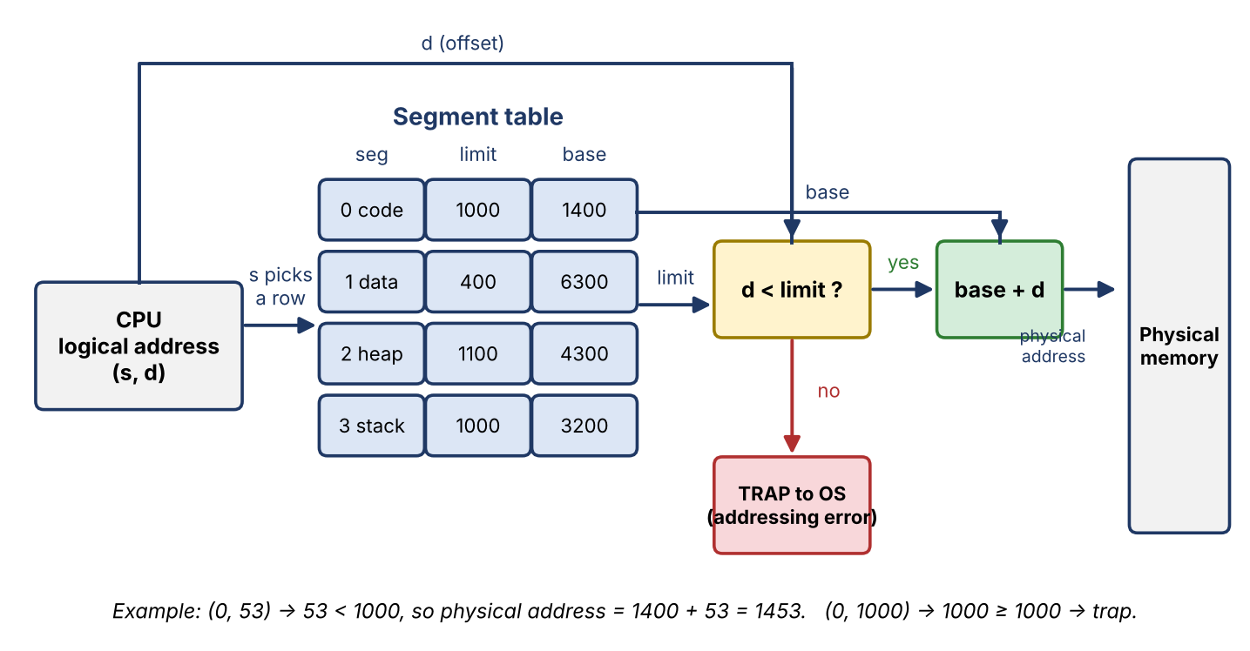
Figure 1: Base-and-limit translation hardware, with the trap path.

1.2 What happens when the offset exceeds the limit
Segment 0 has limit 1000, so its valid offsets are 0 to 999. The address (0, 1000) fails the test d < limit:
- The comparison fails before any memory is touched, so no byte outside the segment is read or written.
- The hardware raises a trap (an addressing-error exception). The CPU switches to kernel mode, saves the program counter and registers and jumps to the OS trap handler.
- The handler sees that the faulting process tried to use an address outside its segment. It does not fix the problem. It sends the process a fatal signal (SIGSEGV on Unix), or terminates it, and may write a core dump.
- Other processes are untouched, because their segments do not overlap. This is the protection the limit register gives.

1.3 Segmentation with paging (Intel x86)
The 32-bit x86 combines both schemes in two stages, shown in Figure 2:
- Segmentation unit. The logical address is a 16-bit selector and a 32-bit offset. The selector's index and its TI bit pick a descriptor in the GDT (global) or LDT (per process). The 8-byte descriptor holds base, limit and access rights. The unit checks the offset against the limit and the access against the rights, then computes linear address = base + offset. A failure raises a general-protection fault.
- Paging unit. The 32-bit linear address is split 10 | 10 | 12 bits. CR3 locates the page directory. The first 10 bits index it to find a page table, the next 10 bits index that to find the page frame, and the last 12 bits are the offset inside the 4 KB frame. A TLB caches recent translations.
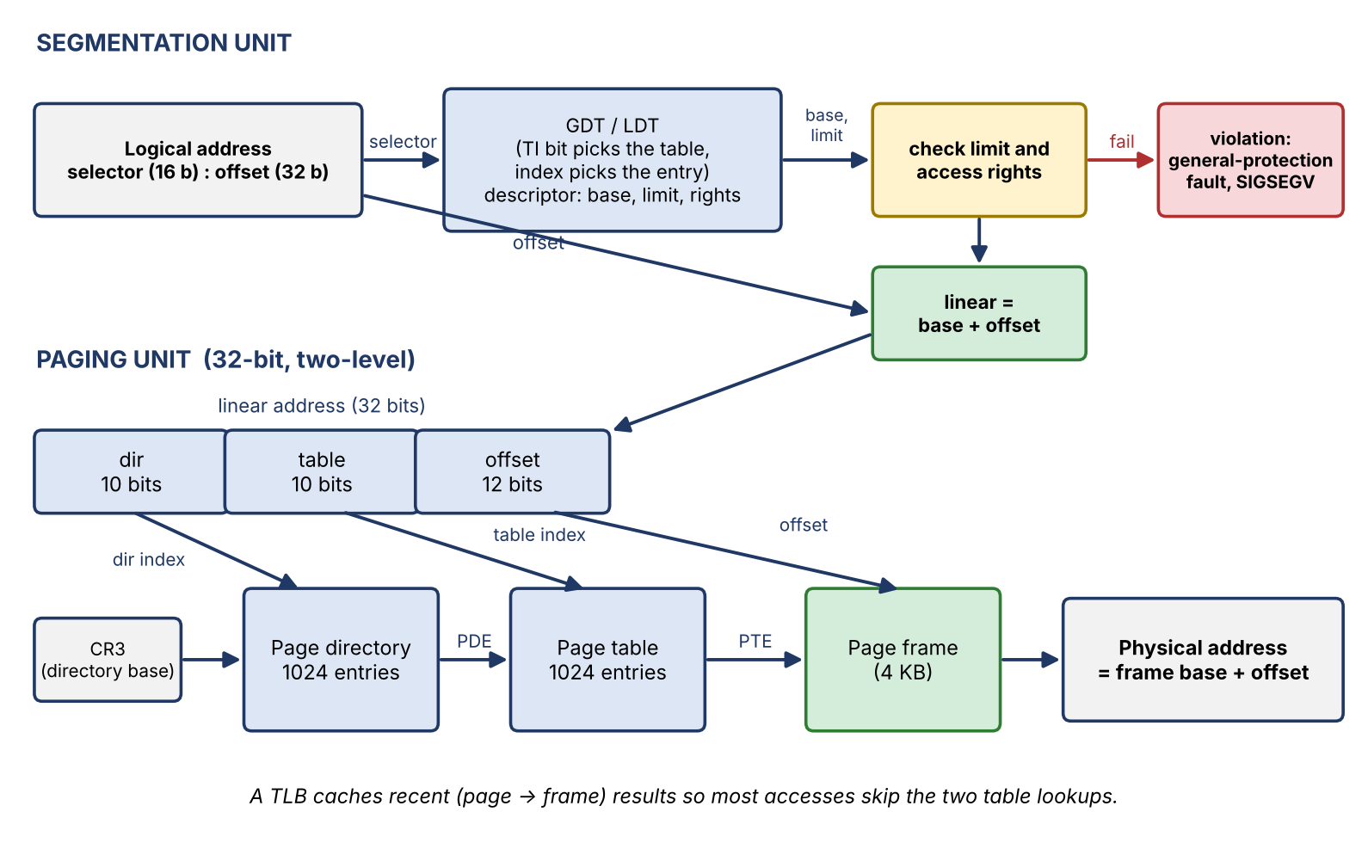
Figure 2: Address translation in 32-bit x86, segmentation followed by two-level paging.
Note on Linux: Linux sets up every segment with base 0 and the maximum limit (the flat model), so the segmentation stage changes nothing and all real protection comes from paging. In 64-bit mode the CPU ignores the base and limit of the code, data and stack segments completely. Only the FS and GS bases are still used, mainly for thread-local storage.

1.4 The segments of a running program on Linux (/proc/<pid>/maps)
Linux keeps a software list of memory regions per process (virtual memory areas, VMAs) that works like a segment table. Program showmaps.c (Appendix C) printed the addresses of its own code, data, heap and stack, then read /proc/<pid>/maps. Selected lines:
pid = 157
code (main) = 0x5653d574c209
.rodata (message) = 0x5653d574d004
.data (initialised) = 0x5653d574f010
.bss (uninit.) = 0x5653d574f024
heap (malloc 100 B) = 0x5653f22192a0
mmap (malloc 1 MB) = 0x7f072c8ff010
stack (local var) = 0x7ffe3cdb489c

5653d574b000-5653d574c000 r--p 00000000 fe:00 532508 showmaps
5653d574c000-5653d574d000 r-xp 00001000 fe:00 532508 showmaps
5653d574d000-5653d574e000 r--p 00002000 fe:00 532508 showmaps
5653d574e000-5653d574f000 r--p 00002000 fe:00 532508 showmaps
5653d574f000-5653d5750000 rw-p 00003000 fe:00 532508 showmaps
5653f2219000-5653f223a000 rw-p 00000000 00:00 0 [heap]
7f072c8ff000-7f072ca00000 rw-p 00000000 00:00 0
7f072ca28000-7f072cbb1000 r-xp 00028000 fe:00 195033 /usr/lib/x86_64-linux-gnu/libc.so.6
7f072cc04000-7f072cc06000 rw-p 00203000 fe:00 195033 /usr/lib/x86_64-linux-gnu/libc.so.6
7f072ccba000-7f072ccbc000 r-xp 00000000 00:00 0 [vdso]
7ffe3cd94000-7ffe3cdb5000 rw-p 00000000 00:00 0 [stack]
Region (address range) | Perms | Segment role
5653d574c000–d574d000 in showmaps | r-xp | Code (.text). The address printed for main (…c209) lies here. Read and execute only, never writable.
5653d574d000–d574e000 and …e000–f000 | r--p | Read-only data (.rodata, relocations). The address printed for message (…d004) lies here.
5653d574f000–d5750000 | rw-p | Data and bss (.data and .bss). The initialised and uninitialised variables are here.
[heap] 5653f2219000–f223a000 | rw-p | Heap (brk). The small malloc(100) result (…192a0) lies here. It grows upward.
7f072c8ff000–7f072ca00000 | rw-p | Anonymous mapping that served malloc(1 MB), 1,028 KB (1 MB + 4 KB header).
libc.so.6 (7f072ca28000–7f072cbb1000) | r-xp | Shared library code, 1.5 MB, shareable. Its own rw-p data region is private.
[stack] 7ffe3cd94000–7ffe3cdb5000 | rw-p | Stack (132 KB now). The local variable's address (…b489c) lies here. It grows downward on demand.

Two points confirm the segment-like view. First, the code is read-only (r-xp) and the data is never executable (rw-p, no x). Second, code is shared: showmaps and two separate runs of cat all map libc.so.6 with the same inode, 195033, at different virtual addresses. The kernel keeps one copy of that file's pages in memory for all of them. The final letter p means private copy-on-write: a write would copy the page, not change the shared one.

2. Evaluation

2.1 How segmentation matches the programmer's view
A programmer thinks of a program as named parts of different sizes: main code, library routines, global data, a heap, a stack. The compiler and linker produce exactly these. Segmentation gives each part its own address space starting at 0, so an address is (part, position inside part). Growth, protection and sharing are then decided per part. Paging by contrast hides this structure: the program is one flat array of equal 4 KB pieces, and the OS cannot tell from the page number whether a page is code, stack or data without extra bits.

2.2 How segments are protected and shared
- Protection: the limit stops a program reading or writing beyond a segment (Section 1.2). The permission bits make code R-X and data RW-, so writing into code, or executing the stack, traps (rows 7 of Table 3.1). Every reference is checked by hardware.
- Sharing: two processes share a segment by putting the same base and limit in their own segment tables. Each student process therefore needs one descriptor to share the compiler's code, and its data and stack segments remain private. In our numbers, 100 processes need 800 bytes of descriptors to share the code segment (Section 3.4).
- Limit of this approach: sharing and protection apply to a whole segment. A segment cannot be partly shared or partly writable.

2.3 External fragmentation caused by segmentation
Segments have different sizes and must be stored contiguously, so freeing and reloading leaves holes of odd sizes. Total free memory may be large while no single hole is large enough. A growing stack or heap makes it worse: if the neighbour is in the way, the segment must be moved or other segments compacted. The measurements are in Section 3.3.

2.3a Comparing pure paging, pure segmentation and segmented paging
 | Pure segmentation | Pure paging | Segmented paging (x86)
Address seen by program | (segment, offset) | One flat number | (segment, offset), converted to a linear address then paged
Unit of allocation | Variable-sized segment | Fixed-size page (4 KB) | Segment, stored in pages
Fragmentation | External (holes between segments) | Internal only (last page, about half a page per region on average) | Internal only (external removed by paging)
Table size (our program, Section 3.4) | 32 B (4 descriptors) | 4 MB single level, or 20 KB two level | 792 B (per-segment page tables) or 20 KB with x86 two-level tables
Translation | Compare and add, table held in registers | Table walk on a TLB miss, 1 to 4 memory accesses | Segment check plus table walk
Sharing | Whole segment, 1 descriptor | Page by page, one PTE per shared page | Whole segment, shared page tables
Protection | Per segment (limit and rights) | Per page (R/W/NX bits) | Both
Growth of stack or heap | May need a move or compaction | Map one more page, no move | Add pages, change limit
Complexity | Simple hardware, hard allocation | Simple allocation, larger tables | Most complex

3. Experimental Investigation

3.1 Eight addresses translated by hand and verified by program
Using the table in Section 1.1. Valid offsets for segment k are 0 to limit−1.
# | (s, d) | Access | Hand working | Result
1 | (0, 53) | R | 0 exists; 53 < 1000; R is allowed in R-X | 1400 + 53 = 1453
2 | (0, 999) | X | 999 < 1000 (last valid byte); X is allowed | 1400 + 999 = 2399
3 | (1, 399) | W | 399 < 400 (last valid byte); W is allowed in RW- | 6300 + 399 = 6699
4 | (2, 1099) | W | 1099 < 1100 (last valid byte); W is allowed | 4300 + 1099 = 5399
5 | (3, 500) | W | 500 < 1000; W is allowed | 3200 + 500 = 3700
6 | (0, 1000) | R | 1000 < 1000 is false | Trap: offset beyond limit
7 | (0, 200) | W | 200 < 1000, but W is not in R-X | Trap: protection violation
8 | (4, 10) | R | Segment 4 is not below the table length 4 | Trap: invalid segment

Program segtrans.c (Appendix A) performs the same checks. Its output:
1 (0, 53) R -> physical 1453 [matches hand calculation]
2 (0, 999) X -> physical 2399 [matches hand calculation]
3 (1, 399) W -> physical 6699 [matches hand calculation]
4 (2,1099) W -> physical 5399 [matches hand calculation]
5 (3, 500) W -> physical 3700 [matches hand calculation]
6 (0,1000) R -> TRAP: offset >= limit [matches hand calculation]
7 (0, 200) W -> TRAP: protection violation [matches hand calculation]
8 (4, 10) R -> TRAP: invalid segment [matches hand calculation]
8 of 8 agree with the hand calculation
All 8 results agree with the hand calculation. Five addresses translate and three correctly trap, one for each trap type.

3.2 Triggering a segmentation fault and what the OS did
Program segfault.c (Appendix B) forks child processes that (1) write into a read-only string and (2) store through address 0x10, which is unmapped. It runs each child first with the default signal action and then with a handler that prints the details. Output:
--- default action (no handler) ---
1. write into read-only .rodata -> killed by signal 11 (Segmentation fault), shell status would be 139
2. store through address 0x10 (unmapped) -> killed by signal 11 (Segmentation fault), shell status would be 139

--- with a SIGSEGV handler (si_code visible) ---
handler: signal 11, faulting address 0x564ccf15f010, si_code=SEGV_ACCERR (region exists, access not permitted)
1. write into read-only .rodata -> exited with status 11
handler: signal 11, faulting address 0x10, si_code=SEGV_MAPERR (address not in any mapped region)
2. store through address 0x10 (unmapped) -> exited with status 11
What the operating system did, step by step:
- The store instruction needed a translation. The MMU found the page not present, or present without write permission, and raised a page-fault exception (#PF on x86).
- The CPU entered kernel mode and ran the kernel's page-fault handler, which received the faulting address.
- The handler searched the process's list of regions (VMAs, the same list as /proc/<pid>/maps) for that address. Case 2: no region contains 0x10, so the fault is unrecoverable and the signal carries si_code SEGV_MAPERR. Case 1: a region exists, but it is read-only, so the signal carries SEGV_ACCERR.
- Valid faults (for example demand paging a page in) would have been fixed and the instruction retried. Here nothing could be fixed, so the kernel sent SIGSEGV (signal 11) to the process.
- With no handler, the default action terminates the process (and may dump core). The parent saw WTERMSIG = 11, which a shell reports as status 128 + 11 = 139 and the words "Segmentation fault". With a handler, the process could run code first, as above, and the faulting addresses were 0x564ccf15f010 (inside .rodata) and 0x10.
The name comes from the days of hardware segments. On today's Linux the check that fires is the page-level one, not a segment limit.

3.3 Fragmentation after loading and removing 20 random segments
Program frag.py (Appendix D) models contiguous memory of 1,600 KB. It loads 20 segments of random size (20 to 120 KB) with first fit, then removes 10 at random. Seed 11 gives these sizes, loaded as S0 to S19: 77, 91, 119, 79, 77, 85, 95, 44, 43, 85, 80, 100, 98, 43, 32, 77, 58, 38, 31, 88 KB, a total of 1,440 KB. Segments S0, S1, S5, S8, S11, S12, S13, S14, S15 and S19 were removed, freeing 734 KB.
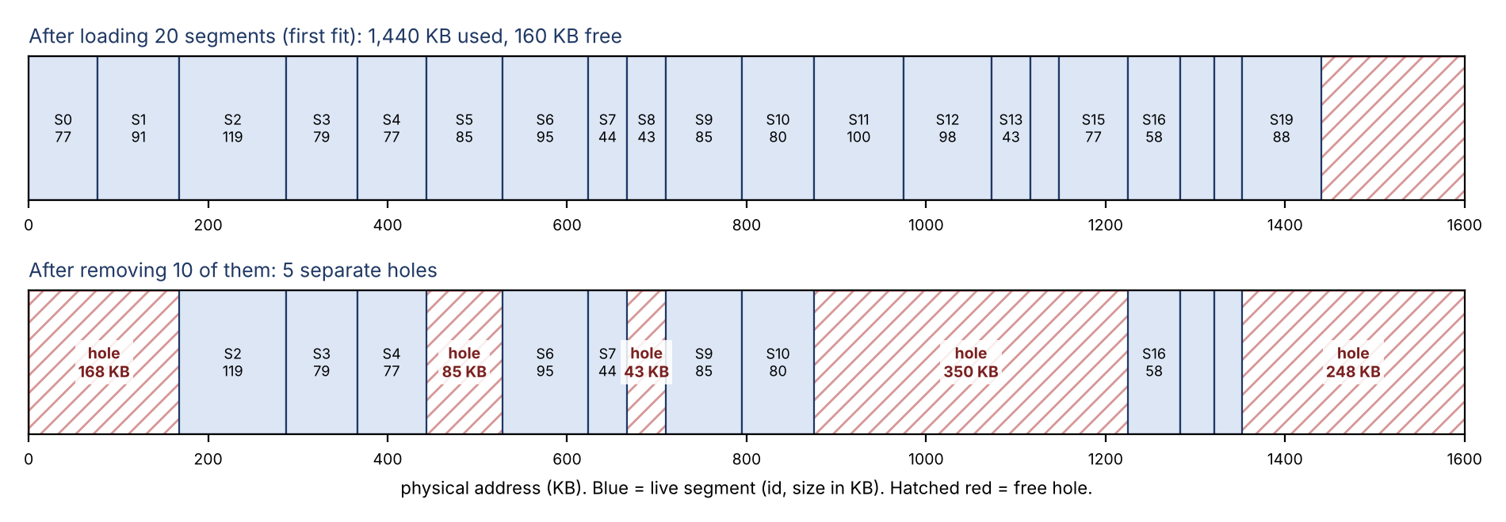
Figure 3: Memory before and after removing 10 of the 20 segments (seed 11).
Measure (seed 11 trace) | Value
Holes | 5 (168, 85, 43, 350, 248 KB)
Total free memory | 894 KB
Largest hole | 350 KB
External fragmentation = (free − largest hole) / free | (894 − 350) / 894 = 60.9%
Free memory in holes under 100 KB | 128 KB = 14.3% of the free memory
Request of 351 KB | Refused: 894 KB is free but the largest hole is 350 KB
Cost to compact | Move 706 KB of live segments
Same 20 segments under paging (4 KB pages) | Internal waste 28 KB (1.40 KB per segment), external 0

Averages over 5,000 random trials (same procedure, then 10 more random segments of 20 to 120 KB are requested):
Placement | Holes | Free (KB) | External fragmentation | Free memory in holes < 100 KB | New segments refused (of 10)
First fit | 5.99 | 909.8 | 62.5% | 16.6% | 0.36
Best fit | 5.99 | 909.8 | 62.5% | 16.6% | 0.26
Worst fit | 5.99 | 909.8 | 62.5% | 16.6% | 0.88

Reading the results: the loading stage is identical for all three policies, because the memory is filled from the bottom with no holes yet. So the first columns match. The difference appears once new segments must fit into the holes: best fit refused the fewest and worst fit the most. In every case, about 60% of the free memory was outside the largest hole, and requests failed although enough memory was free in total. Compaction would cure this, but it copies hundreds of KB (706 KB here) and the processes must be stopped meanwhile. Paging has no such problem, since any free frame serves any page.

3.4 Size of the tables in each scheme
Program tables.py (Appendix E) used one student program: code 202 KB, data 150 KB, heap 301 KB, stack 98 KB (751 KB), a 32-bit address space, 4 KB pages, 4-byte page-table entries and 8-byte segment descriptors.
Scheme | Table size | How it was found
Pure segmentation | 32 B | 4 segments × 8 B
Pure paging, single level | 4 MB | 2²⁰ pages × 4 B, whether used or not
Pure paging, two level | 20 KB | 1 directory + 4 page tables (4 regions) = 5 × 4 KB
Segmented paging, one page table per segment | 792 B | 32 B descriptors + 190 PTEs × 4 B (51 + 38 + 76 + 25 pages)

- Sharing the 51-page code segment among 100 processes: segmentation needs 100 × 8 B = 800 B of descriptors. Paging needs 51 PTEs per process, 100 × 51 × 4 B = 20,400 B.
- Single-level page tables would cost 400 MB for 100 processes (100 × 4 MB), which is why real systems use multi-level tables.
- Translation time (assumed 1 ns TLB, 100 ns memory, 98% TLB hit ratio): segmentation with registers 100 ns; paging with a 1-level walk 103 ns, 2-level 105 ns, 4-level 109 ns. Segmented paging costs the same as paging, because the segment check happens in registers.

4. Conclusion: Why Modern Operating Systems Rely Mainly on Paging
- No external fragmentation. Fixed-size frames mean any free frame serves any page. Segmentation left 60% of the free memory unusable in our test, and compaction was costly.
- Simple, fast allocation. The OS needs only a free-frame list, not a search for a hole that fits.
- Virtual memory fits pages. Demand paging, swapping and copy-on-write all work on equal-sized pieces. Moving a whole variable-sized segment to disk is slow and awkward.
- Paging can give most of what segments gave. Per-page read, write and no-execute bits protect code and data. Shared libraries are shared by mapping the same frames (one libc inode in all our processes). The OS keeps a software segment list (VMAs, /proc maps) for the programmer's view.
- Portability and 64-bit mode. Many architectures have no segmentation at all, and 64-bit x86 ignores segment bases and limits. Linux uses the flat model.
- Table cost is manageable. Multi-level tables only allocate what is used (20 KB instead of 4 MB), and a TLB hides the walk (105 ns against 100 ns).
So segmentation survives as an idea, not as hardware: the logical view of code, data, heap and stack remains in the OS's region lists, while paging does the actual memory management.

Alternative Concept and Complexity Analysis
If the programs used pure paging instead of segmentation. The program is one flat address space. The OS divides it into 4 KB pages, keeps one page table per process, and marks each page R, W or X. Code, data, heap and stack are just ranges of pages.
Criterion | Pure segmentation | Pure paging | Evaluation
Fragmentation | External: 60.9% of free memory in unusable holes in our trace. Internal: none. | Internal only: 9 KB for the 4 regions of the sample program (about half a page per region expected). External: 0. | Paging better. Waste is bounded by one page per region.
Table size | 32 B per process for 4 segments. | 4 MB single level, or 20 KB two level. | Segmentation smaller, but multi-level paging keeps the cost small.
Time to translate | 100 ns: compare and add with the table in registers. | 103, 105 or 109 ns with a 1-, 2- or 4-level walk and a 98% TLB hit ratio (assumed). A TLB miss costs 1 to 4 extra memory accesses. | Segmentation slightly faster, with the TLB closing most of the gap.
Sharing code | 1 descriptor per process (800 B for 100 processes). | 51 PTEs per process (20,400 B for 100 processes), all pointing to the same frames. | Segmentation simpler. Paging shares well but needs the OS to keep the pages consistent.
Protection | Limit plus rights per segment, checked by hardware. | R/W/NX bits per page. Out-of-range addresses fault because no page is mapped there. | Equal in effect: paging is finer-grained but the OS must set bits for every page of a region.
Stack growth | Needs a larger limit and possibly a move. | Map one more page on a fault, no move. | Paging better.

Verdict: pure paging trades a larger table and a little extra translation time for the removal of external fragmentation, simpler allocation and easy growth. That trade is why it won. The only real loss is that sharing and protection are done page by page instead of with a single descriptor, which the OS hides behind its region lists.

Appendix A – segtrans.c
// segtrans.c - (segment, offset) -> physical address using a segment table with base, limit, permissions
// Build: gcc -O2 -o segtrans segtrans.c
#include <stdio.h>
#include <string.h>

typedef struct { const char *name; unsigned base, limit; const char *perm; } Seg;

static Seg table[] = { /* segment table of one student's process */
{"code", 1400, 1000, "R-X"}, /* read-only, shareable */
{"data", 6300, 400, "RW-"},
{"heap", 4300, 1100, "RW-"},
{"stack", 3200, 1000, "RW-"},
};
#define NSEG ((int)(sizeof table / sizeof table[0]))

typedef struct { int seg; unsigned off; char acc; long expect; } Test; /* expect = hand-calculated result */

/* returns physical address, or -1 invalid segment, -2 offset >= limit, -3 protection violation */
static long translate(int s, unsigned off, char acc){
if (s < 0 || s >= NSEG) return -1; /* segment number beyond the table length */
if (off >= table[s].limit) return -2; /* offset beyond limit: trap to the OS */
if (!strchr(table[s].perm, acc)) return -3; /* e.g. write to the read-only code segment */
return (long)table[s].base + off;
}

int main(void){
Test t[] = {
{0, 53,'R', 1453}, {0, 999,'X', 2399}, {1, 399,'W', 6699}, {2,1099,'W', 5399},
{3, 500,'W', 3700}, {0,1000,'R', -2}, {0, 200,'W', -3}, {4, 10,'R', -1},
};
int ok = 0;
for (int i = 0; i < 8; i++){
long r = translate(t[i].seg, t[i].off, t[i].acc);
printf("%d (%d,%4u) %c -> ", i+1, t[i].seg, t[i].off, t[i].acc);
if (r >= 0) printf("physical %-5ld ", r);
else if (r == -1) printf("TRAP: invalid segment ");
else if (r == -2) printf("TRAP: offset >= limit ");
else printf("TRAP: protection violation ");
printf("[%s]\n", r == t[i].expect ? "matches hand calculation" : "MISMATCH");
ok += (r == t[i].expect);
}
printf("%d of 8 agree with the hand calculation\n", ok);
return 0;
}

Appendix B – segfault.c
// segfault.c - trigger two kinds of segmentation fault in child processes and report what the kernel did
// Build: gcc -O0 -o segfault segfault.c
#define _GNU_SOURCE
#include <stdio.h>
#include <stdlib.h>
#include <string.h>
#include <signal.h>
#include <unistd.h>
#include <sys/wait.h>

static const char rodata[] = "read-only string"; /* lives in a read-only segment (.rodata) */
static int use_handler;

static void handler(int sig, siginfo_t *si, void *ctx){
(void)ctx; char buf[160];
int n = snprintf(buf, sizeof buf, " handler: signal %d, faulting address %p, si_code=%s\n", sig, si->si_addr,
si->si_code == SEGV_MAPERR ? "SEGV_MAPERR (address not in any mapped region)"
: "SEGV_ACCERR (region exists, access not permitted)");
write(1, buf, n); _exit(11);
}

static void child(int kind){
if (use_handler){ struct sigaction sa; memset(&sa,0,sizeof sa); sa.sa_sigaction = handler; sa.sa_flags = SA_SIGINFO;
sigaction(SIGSEGV, &sa, NULL); }
if (kind == 1){ volatile char *p = (char*)rodata; p[0] = 'X'; } /* write to read-only memory */
else { volatile int *p = (int*)0x10; *p = 42; } /* offset far outside every mapped region */
_exit(0);
}

int main(void){
const char *what[] = {"", "write into read-only .rodata", "store through address 0x10 (unmapped)"};
for (use_handler = 0; use_handler <= 1; use_handler++){
printf(use_handler ? "\n--- with a SIGSEGV handler (si_code visible) ---\n" : "--- default action (no handler) ---\n");
for (int k = 1; k <= 2; k++){
fflush(stdout);
pid_t pid = fork();
if (pid == 0) child(k);
int st; waitpid(pid, &st, 0);
printf("%d. %-40s -> ", k, what[k]);
if (WIFSIGNALED(st)) printf("killed by signal %d (%s), shell status would be %d\n", WTERMSIG(st), strsignal(WTERMSIG(st)), 128+WTERMSIG(st));
else printf("exited with status %d\n", WEXITSTATUS(st));
}
}
return 0;
}

Appendix C – showmaps.c
Build: gcc -O0 -o showmaps showmaps.c. Run ./showmaps.
// showmaps.c - print where this program's code, data, bss, heap and stack are, then its own /proc/self/maps
// Build: gcc -O0 -no-pie -o showmaps_nopie showmaps.c (or default PIE build: gcc -O0 -o showmaps showmaps.c)
#include <stdio.h>
#include <stdlib.h>
#include <unistd.h>

int initialised = 7; /* .data */
int uninitialised; /* .bss */
const char message[] = "hello"; /* .rodata */

int main(void){
int local = 0; /* stack */
void *heap = malloc(1 << 20); /* 1 MB: served by mmap; a small malloc would use [heap] */
void *small = malloc(100); /* small: served from [heap] (brk) */
printf("pid = %d\n", getpid());
printf("code (main) = %p\n", (void*)main);
printf(".rodata (message) = %p\n", (void*)message);
printf(".data (initialised) = %p\n", (void*)&initialised);
printf(".bss (uninit.) = %p\n", (void*)&uninitialised);
printf("heap (malloc 100 B) = %p\n", small);
printf("mmap (malloc 1 MB) = %p\n", heap);
printf("stack (local var) = %p\n\n", (void*)&local);
fflush(stdout);
char cmd[64]; snprintf(cmd, sizeof cmd, "cat /proc/%d/maps", getpid());
system(cmd); /* the shell child reads OUR pid's maps */
return 0;
}

Appendix D – frag.py
Run: python3 frag.py. Fixed seeds make the output reproducible.
# frag.py - external fragmentation after loading and removing 20 random-size segments (contiguous segment allocation)
import random, statistics as st

MEM = 1600 # KB of physical memory
PAGE = 4 # KB page size for the paging comparison
REQ = 100 # KB: a later request used to test whether free memory is still usable

def holes(allocs): # allocs: list of (start, size, id) sorted by start
out, pos = [], 0
for s, z, _ in allocs:
if s > pos: out.append((pos, s - pos))
pos = s + z
if pos < MEM: out.append((pos, MEM - pos))
return out

def place(allocs, size, policy):
hs = [h for h in holes(allocs) if h[1] >= size]
if not hs: return None
h = {'first': hs[0], 'best': min(hs, key=lambda x: x[1]), 'worst': max(hs, key=lambda x: x[1])}[policy]
return h[0]

def trial(rnd, policy):
while True: # draw 20 sizes; redraw in the rare case they cannot all be loaded
sizes = [rnd.randint(20, 120) for _ in range(20)]
allocs = []; ok = True
for i, z in enumerate(sizes):
s = place(allocs, z, policy)
if s is None: ok = False; break
allocs.append((s, z, i)); allocs.sort()
if ok: break
removed = set(rnd.sample(range(20), 10))
allocs = [a for a in allocs if a[2] not in removed]
return sizes, removed, allocs

def churn(rnd, allocs, policy, n=10):
"""After the removals, try to load n new segments of 20-120 KB. Returns (loaded, failed_though_enough_total_free)."""
loaded = failed = 0; nid = 100
for _ in range(n):
z = rnd.randint(20, 120)
free = sum(h[1] for h in holes(allocs))
s = place(allocs, z, policy)
if s is None:
if free >= z: failed += 1 # enough memory in total, but not in one piece
else:
allocs.append((s, z, nid)); allocs.sort(); nid += 1; loaded += 1
return loaded, failed

def metrics(allocs):
hs = holes(allocs); free = sum(h[1] for h in hs); big = max(h[1] for h in hs)
unusable = sum(h[1] for h in hs if h[1] < REQ)
return hs, free, big, (free - big) / free, unusable / free

# ---------- one detailed, reproducible trace (first fit, seed 11) ----------
rnd = random.Random(11)
sizes, removed, allocs = trial(rnd, 'first')
print("Segment sizes (KB), loaded in order 0..19 by first fit:")
print(sizes, " total =", sum(sizes), "KB of", MEM, "KB")
print("Removed segments:", sorted(removed), " freed =", sum(sizes[i] for i in removed), "KB")
hs, free, big, frag, unus = metrics(allocs)
print("Holes (start KB, size KB):", hs)
print("holes = %d, total free = %d KB, largest hole = %d KB" % (len(hs), free, big))
print("external fragmentation = (free - largest)/free = %.1f%%" % (frag * 100))
print("free memory in holes smaller than %d KB (unusable for a %d KB request) = %.1f%%" % (REQ, REQ, unus * 100))
req = big + 1
print("a request of %d KB: total free %d KB >= request, but largest hole %d KB -> FAILS without compaction" % (req, free, big))
_a = list(allocs); _l, _f = churn(random.Random(5), _a, 'first')
print("then 10 new segments (20-120 KB) are requested: %d loaded, %d refused although total free memory was large enough" % (_l, _f))
first_hole = hs[0][0]
moved = sum(z for s, z, _ in allocs if s > first_hole)
print("compaction would move %d KB of live segments" % moved)
waste = sum((-z) % PAGE for z in sizes)
print("Same 20 segments under paging (%d KB pages): internal waste = %d KB (avg %.2f KB per segment), external = 0" % (PAGE, waste, waste/20))

# ---------- 5,000 random trials per placement policy ----------
print("\n5,000 trials, memory %d KB, 20 segments of 20-120 KB, 10 random removals:" % MEM)
print("%-10s %7s %9s %13s %20s %26s" % ("policy", "holes", "free KB", "ext. frag %", "unusable for %dKB %%" % REQ, "refused of 10 new (avg)"))
for pol in ('first', 'best', 'worst'):
r = random.Random(2024); H, F, X, U, RF, LD = [], [], [], [], [], []
for _ in range(5000):
_, _, a = trial(r, pol)
hs, free, big, fr, un = metrics(a)
H.append(len(hs)); F.append(free); X.append(fr * 100); U.append(un * 100)
ld, fl = churn(r, a, pol); RF.append(fl); LD.append(ld)
print("%-10s %7.2f %9.1f %13.1f %20.1f %26.2f" % (pol + " fit", st.mean(H), st.mean(F), st.mean(X), st.mean(U), st.mean(RF)))

Appendix E – tables.py
Run: python3 tables.py.
# tables.py - size of the translation tables for one student program under each scheme (32-bit, 4 KB pages)
import math
PAGE, PTE, DESC = 4096, 4, 8 # page size, page-table entry (bytes), x86 segment descriptor (bytes)
KB = 1024
seg = {"code": 202*KB, "data": 150*KB, "heap": 301*KB, "stack": 98*KB} # one program; varying sizes
total = sum(seg.values()); n = len(seg)
pages = {k: math.ceil(v/PAGE) for k, v in seg.items()}
print("program: %s total = %d KB" % (", ".join("%s %d KB" % (k, v//KB) for k, v in seg.items()), total//KB))
print("pages per segment:", pages, " total pages =", sum(pages.values()))

# 1. pure segmentation: one (base, limit) pair per segment. Base and limit 4 B each = 8 B (add flags/permissions as needed)
t_seg = n * 8
# 2. pure paging, single level: one PTE for every page of the whole 2^32 address space, used or not
t_page1 = (2**32 // PAGE) * PTE
# 3. pure paging, two level (x86 32-bit): 1 directory page + one 4 KB table per 4 MB region touched.
# regions touched: code, data, heap, stack placed in 4 different 4 MB regions (typical layout) -> 4 tables
t_page2 = PAGE + 4 * PAGE
# 4. segmented paging, one page table per segment (MULTICS style): segment table + sized-to-fit page tables
t_segpage = n * DESC + sum(pages.values()) * PTE
print("\n%-52s %12s" % ("scheme", "bytes"))
print("%-52s %12d" % ("pure segmentation (4 x 8 B)", t_seg))
print("%-52s %12d (= %d MB)" % ("pure paging, single level (2^20 PTEs x 4 B)", t_page1, t_page1//(KB*KB)))
print("%-52s %12d (= %d KB)" % ("pure paging, two level (1 dir + 4 tables)", t_page2, t_page2//KB))
print("%-52s %12d" % ("segmented paging, table per segment (32 B + PTEs)", t_segpage))

# internal fragmentation (last page of every segment/region)
waste = sum(pages[k]*PAGE - seg[k] for k in seg)
print("\ninternal fragmentation in the last page of each region: %d bytes (%d KB)" % (waste, waste//KB))

# sharing the code segment between 100 student processes
P, cp = 100, pages["code"]
print("\nsharing the %d-page code segment between %d processes:" % (cp, P))
print(" segmentation: 1 descriptor each = %d B total" % (P*DESC))
print(" paging: %d PTEs each = %d B total" % (cp, P*cp*PTE))
print("100 processes, single-level page tables alone: %d MB" % (P*t_page1//(KB*KB)))

# effective access time (assumed 1 ns TLB, 100 ns memory, 98% TLB hit ratio)
tlb, mem, hit = 1, 100, 0.98
eat = lambda walk: hit*(tlb+mem) + (1-hit)*(tlb+walk*mem+mem)
print("\nEffective access time (TLB %d ns, memory %d ns, hit ratio %.0f%%):" % (tlb, mem, hit*100))
print(" segmentation only (table in registers): %.1f ns" % mem)
print(" paging, 1-level walk: %.1f ns, 2-level walk: %.1f ns, 4-level walk: %.1f ns" % (eat(1), eat(2), eat(4)))
print(" segmented paging (x86): segment check in registers, then the paging cost above = %.1f ns (2-level)" % eat(2))

